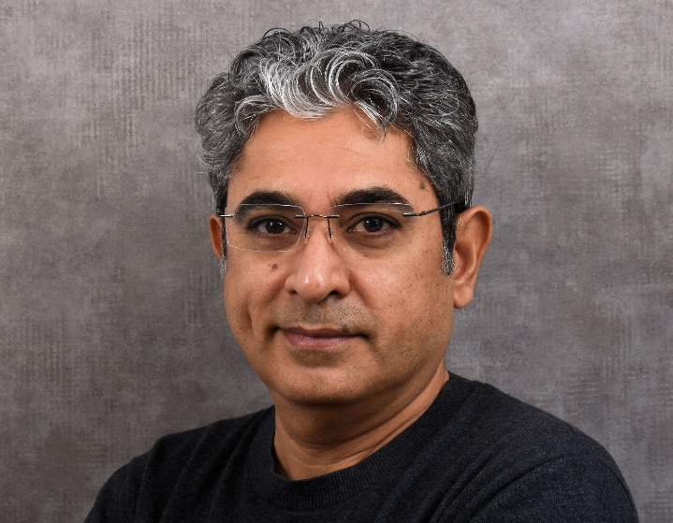
Manoj BHATIA
Address : Hartenfelsstrasse 17, 6030 Ebikon
Date of birth : 19. November 1973
Phone : 078 234 2354
Marital status : Married with 2 kids
Nationality : Swiss
Linkedin : https://www.linkedin.com/in/manoj-udhav-bhatia/

SOFTWARE ENGINEER
A Senior Software Engineer with a strong focus on delivering quality solutions in collaboration with cross-cultural and cross-functional teams. A relentless learner, pragmatic, adaptable and trustworthy with a streak of creativity. A problem solver, an integrator with good communication skills and a get-it-done mindset, ready to switch hats, take lead and add value. Experienced in designing software architectures for real-time embedded control systems, adaptable to distributed RT architectures.

KNOWLEDGE BASE
Domain : Embedded systems, Industrial Automation, IoT
Languages : C | C++ | Python | PHP | Javascript | Shell-scripting | PL/SQL | PLC
OS : Linux (headless) | FreeRTOS | ROS | RTEMS | VxWorks | eCOS | uCOS
Interfaces : TCP/UDP | SPI | I2C | UART | CAN | Radar | LoRa | BT | RFID | Wifi |
Ethernet | RS-232 | RS-485 | GPIO | REST | MQTT | CoAP | SOAP
Frameworks & Tools : React.js | Flask | GIT | SVN | JIRA | Jenkins
Development Practices: Agile | CI/CD | TDD | Clean Code | Design Patterns
Familiarity : STL | Design Patterns | ROS | IoT Stack | Sensors | Microservice | Web Development | Streamlit | API | DataAnalysis | AI/ML | AI Agent |
DevOps | RAG | Vibe Coding | Grafana | InfluxDB | Node-Red

EXPERIENCE
Self-Initiated Learning and Techincal Curiosity Dec 2024 – till date
Continually exploring new technologies and paradigms beyond formal work, including:
• N8N and AI-automated workflows
• Retrieval-Augmented Generation (RAG)
• Agentic AI systems and prompt engineering
• ML fundamentals and AI-assisted software tooling
• Fullstack engineering from embedded systems to web UX (ESP32, Arduino, Streamlit, React.js, Flask)
• Typescript, PostgreSQL, TailwindCSS, MySQL,
• Exploring robotics software stacks (ROS, Gazebo), computer vision with OpenCV, and basics of SLAM algorithms

Employer : Schindler Elevators, Switzerland Jan 2017 – Nov 2024
Project : Diagnostic Tool Jan 2020 – Nov 2024
Platform : C++ | Python | PHP | Linux | Apache | Agile
Effort : IoT based hybrid log capturing system | Harmonized dashboard | Pattern recognition for root cause analysis | Automated repetitive support analysis | Adaptive diagnostics | FOTA | Playlist application for log sniffing | Relevant analytics for developers and management.

Project : Inverter Control Jan 2017 – Nov 2024
Platform : STM32 | C | C++ | CAN | RS422 | RS485 | JIRA | GIT | SVN | Jenkins | HIL
Effort : Release management | Software development | Extreme programming | Field visits | Operations for department JIRA, SVN, Jenkins servers | Microservice for licensing of diagnostic tool | Field Support | Training

Employer : Capgemini, Switzerland Jan 2000 - July 2017
Project : NX, Schindler Elevators May 2016 – Dec 2016
Platform : C++ | PowerPC | Embedded Linux | Rational Rose
Effort : Cross-platform component interfacing | Scripting code from Rational Rose Capsule to C++

Project : PF91, Schindler Elevators Mar 2002 - Apr 2016
Platform : C++ | C | GNU compilers | Motorola CF54 | Lauterbach | Visionclick | CAN | Echelon
Effort : Program Management | Coordination onsite-offshore team | Planning milestones | Cross-functional | Cross-cultural | Business development | Training team | Pragmatic work distribution | Revival the cashcow software platform from phase- out to mainstay | Control team turnover | Field support | Taskforce for high profile clients | Won developer awards | Fast track program | Solution Presentations
Project : Porting code, Schindler Elevators May 2001 – Feb 2002
Platform : C++ | Delphi 5 | Rational Rose
Effort : Team Lead | Porting Delphi to C++ | Cross-language Interface | Extreme programming | Code reviews | Module integration | Integration testing.

Project : Data Warehousing (DWH), GE-Plastics, Holland Mar 2000 – June 2000
Platform : COBOL, Oracle 7.3, PL/SQL, and TOAD.
Effort : Scripts to transfer Mainframes data to Oracle DB with data normalization.

Employer : Siemens, India Aug 1995 – Jan 2000
Project : Cement Plant Automation, India and Philippines
Platform : S5-155U PLCs, SINEC-H1, Simatic Step5, HMI on COROS-LSB/LSC.
Effort : Engineering | Commissioning | Hot-standby | Minimal click GUI for Plant visualization | MIS Reporting | Recipe-based Control | Training Field engineers / Operators | System Handover

Project : Activity Based Costing for Repairs
Platform : Excel | VB Macro
Effort : Executive MBA Program Best Prize Award | Derive real cost of Repairs | Convert paradigm of repairs from pure profitability to customer service business

EDUCATION

Bachelor of Engineering with Distinction, Honors, Bombay University 1991 - 1995

Marketing Management Programme, Indian Institute of Management, Bangalore 1998 - 3 month

HOBBIES
Tennis, cricket, football, table tennis, cycling.
Fullstack engineering, spanning embedded software to UX.
Enthusiastic on Arduino, ESP32 related work and 3D space coordinate estimation.

LANGUAGES
English (fluent) | German (conversational, B1: improving) | Hindi (fluent)

